
Form 1, Unit 2 – Qin Dynasty, Han Dynasty, National Education
Worksheet
The Han Tomb of
Lei Cheng Uk
姓名：
班別：
Pottery house models unearthed from The Han Tomb of
Lei Cheng Uk
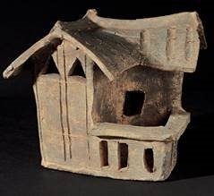
From observing the pottery house models unearthed from The Han Tomb of Lei Cheng Uk , we can get a glimpse of people’s everyday lives during the Han Dynasty. For example, as models featuring animal pens, rice pounders, and winnowing fans, we can tell that despite being a coastal region, Hong Kong people back then made their livings from farming and herding livestock. We can tell from the models that h ouses then built with wooden pillars, mud and clay walls, and tiled roofs. As pottery house models are common grave goods in the Eastern Han Dynasty, we can deduce that the Han culture of central China has reached Hong Kong 2,000 years ago.
Pottery house model with animal pen
- What can we tell from the pottery house models about the livelihoods of Hong Kong residents back then?
  - They mostly make a living from fishery
  - They mostly produce rice
  - They mostly trade and commerce

  - Their houses are made of stone and bricks
- The picture below is a pottery house model unearthed from the Eastern Han Tomb in Guangzhou Zoo. Do you think it’s similar to that of The Han Tomb of Lei Cheng Uk ? Explain.
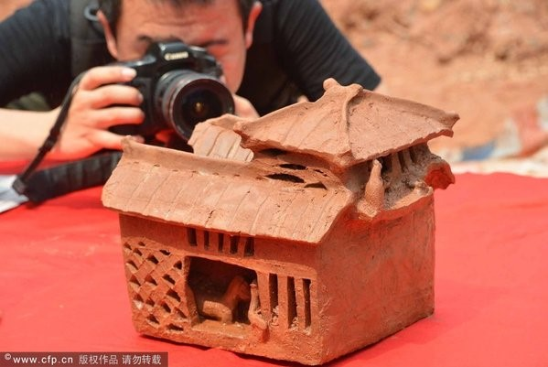
3. Following the previous question, what are your thoughts after observing pottery house models from different regions?

Answer：
- B
- Yes. They look similar and both have animal pens.
- Any reasonable answer.

