
Justice
Worksheet
Man Mo Temple
姓名：
班別：
The Chinese “justice” system in the early days after
the Founding of Hong Kong
“The Gods are three feet above you (舉頭三尺有神明)” is a prominent traditional Chinese belief. As people are unlikely to lie before the Gods, deities, or spirits, disputes are often resolved at Man Mo Temple, rather than involving the police force or the court. The litigator will bring a rooster to the temple, and perform the ritual of “beheading the rooster, burning the charm (斬雞頭，燒黃紙)” before the temple’s acolyte. Chinese gentries prefer to hold meetings in Man Mo Temple, not only because it's conveniently located and spacious, but also because meetings held in the presence of the temple’s deities are seen as more credible. The district office outside of Man Mo Temple is also seen as a pseudo-justice
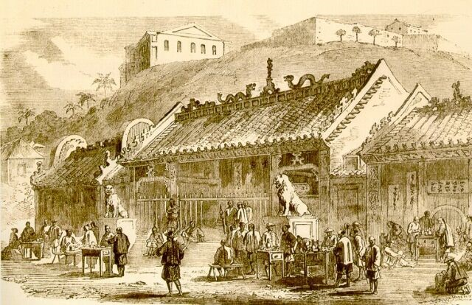
system, demonstrating the Chinese population’s preference to handle justice themselves, instead of involving the colonial government.
Pottery house model with animal pen
- What is the ritual performed by the litigator at Man Mo Temple to resolve dispute?
  - Lion Dance
  - Sounding the drums
  - Burning the charm

  - Cutting the suckling pig
- Which of the following is NOT why Chinese gentries prefer to meet at Man Mo Temple?
  - The temple is spacious
  - The temple is conveniently located
  - The temple is free of charge

  - The temple makes the meeting more credible
3. If you need to resolve conflict, would you do it in a religious location before deities?

Answer：
- C
- C
- Any reasonable answer.

