
Chinese Architecture, Geography of China, Chinese History

Worksheet
Hau Wong Temple
姓名：
班別：
The ‘Five Peaks pay tribute to heaven’ stepped garble
Hau Wong Temple in Kowloon City stands on a masonry terrace, and the altars are placed in the rear hall of the main temple building. The stepped gables of the rear hall are built in the style known as ‘Five Peaks pay tribute to heaven’ (五嶽朝天), a very rare design that is seldom found in Hong Kong.
‘Five Peaks pay tribute to heaven’ originates from the Hui Style Architecture, referring to the five-lap walls which were between and higher than the two gable roof walls, resembling five mountain peaks. Taoism believes that fairies and gods live on the Five Peaks, and using ‘Five Peaks pay tribute to heaven’ is seen as a good omen.
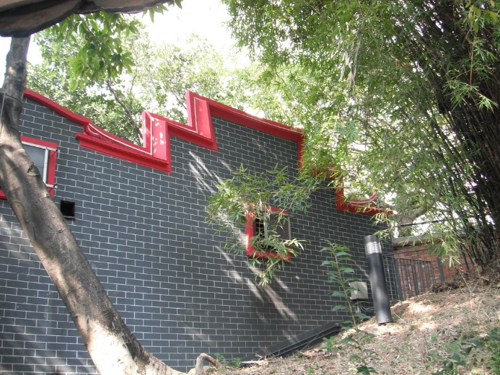
This architecture also prevents the spreading of fire to nearby buildings in case of a fire, and was also known as a fire seal wall.

- What design was used in the Hau Wong Temple’s stepped gables of the rear hall?
  - Fire seal mountains
  - Five Peaks pay tribute to heaven
  - Five Peaks overlapping

  - The ups and downs of mountains
- Following the previous question, what practical purpose does this design have?
  - Prevents the spreading of fire to nearby buildings
  - A Taoism symbol to pay homage to the deities
  - Attract donations from worshippers

  - Prevents thieves from entering
3. After this visit, do you believe that traditional Chinese architecture is beautiful, practical, and meaningful?

Answer：
- B
- A
- Any reasonable answer.

