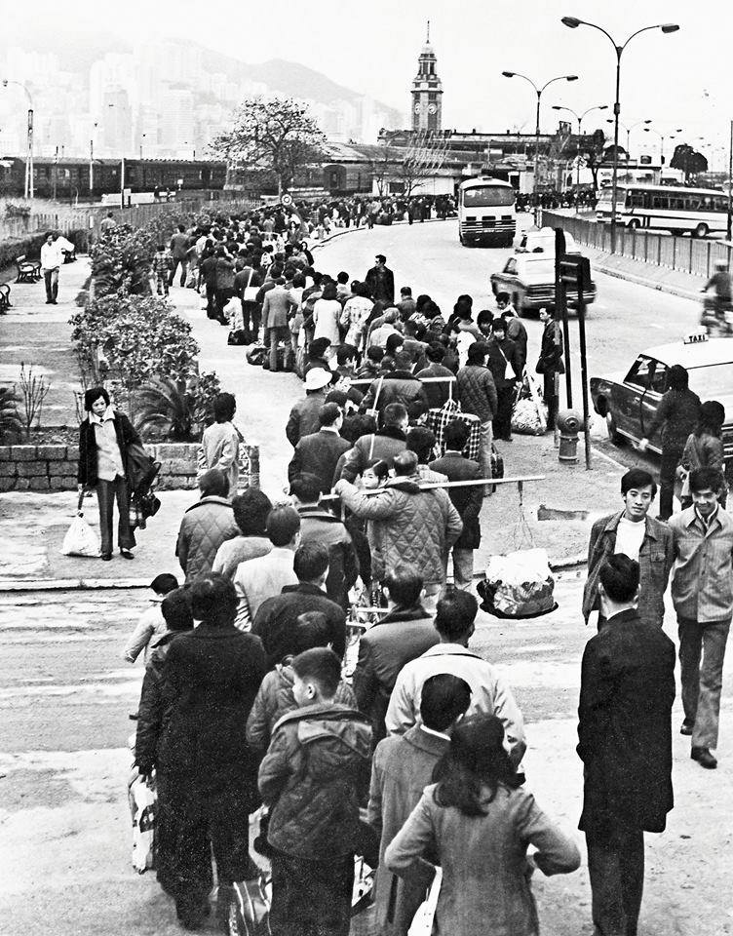

Form 3, Unit 2: Unity, Caring, National Identity
Worksheet
Former Kowloon-Canton
Railway Clock Tower
姓名：
班別：
Former Kowloon-Canton Railway Clock Tower

In the 1960s to 70s, many from mainland China illegally immigrated to Hong Kong. This influx of workforce helped boost Hong Kong’s economy, and they often return to their homeland to financially assist their family and friends. It is common practice to see these people traveling to mainland China carrying lots of goods and resources during Lunar New Year, Tomb Sweeping Day, and other traditional Chinese holidays.
As China back then was running a strict planned economy, many daily necessities, such as rice, cloth, and oil, can only be exchanged with designated tickets, and effectively became priceless.

- What did those who illegally immigrated to Hong Kong in the 1960s and 70s do?

- What did they bring with them to their homeland?

3. How would you respond to family and friends who need dire help?

Answer：
- Assist them financially
- Goods, resources, and daily necessities
- Any reasonable answer.

