
Empathy
Worksheet
Blake Garden
姓名：
班別：
Residence after the early Founding of
Hong Kong Chinese population
The location of the current Blake Garden was highly populated with mainland Chinese in the early days after the Founding of Hong Kong. As the population in the area were mostly low-income, the residences were densely populated with poor sanitary conditions, which
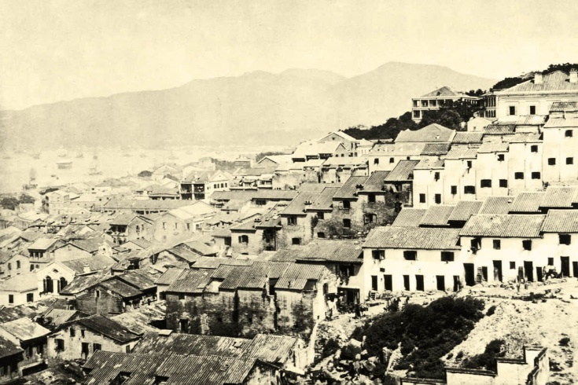
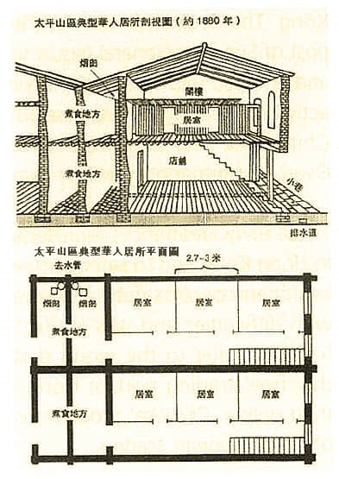
ultimately lead to the outbreak of the bubonic plague in 1894, causing over 2500 death between May and September. In response, the buildings in the area were bought and demolished by the government, with the worst affected area redeveloped to much higher sanitary standards.

- What difficulties did the early Founding of Hong Kong Tai Ping Shan residents face?
  - Traffic congestion
  - Dense population and poor sanitary conditions
  - Insufficient entertainment facilities

  - Lack of education
- What was the government’s response to the outbreak of bubonic plague in 1894?
  - Provide medical aid
  - Buildings in the area were bought, demolished, and redeveloped
  - Increase the number of public toilets

  - Relocated the residents of Tai Ping Shan
3. The poor sanitary conditions of Tai Ping Shan led to the plague outbreak in 1894. What are your thoughts on the importance of living conditions?

Answer：
- B
- B
- Any reasonable answer.

