
Empathy, Caring
Worksheet
Kwong Fuk Ancestral Hall
姓名：
班別：
Respite for the homeless
In the early days after the Founding of Hong Kong, many homeless Chinese gathered around Tai Ping Shan Street, who mostly worked in man
ual labour. After their passing, many did not have the resources to have their remains sent back to mainland China, leaving their “souls” behind. As such, Kwong Fuk Ancestral Hall (廣福義祠) was funded and built in 1851 to house the tablets of mainland Chinese who worked and died in Hong Kong, where they may be sent back to their homeland later. As the those who had their tablets housed came from all across the country, the I-tsz was also
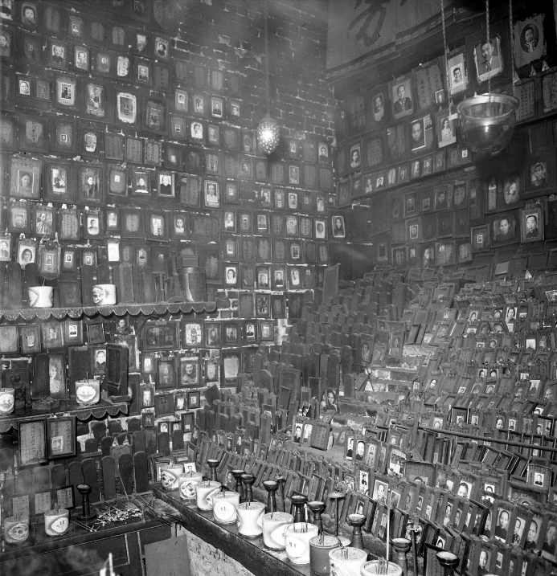
called “Pak Shing Temple (百姓廟)”. The temple was refurbished in recent years to pay better respect to those who came before. Observing where the tablets originate from will give a deeper meaning to “Pak Shing”, which stands for “a hundred surnames”.

- Which of the following is an appropriate description of the livelihood of the Chinese who lived in Tai Ping Shan Street in the early days after the Founding of Hong Kong?
  - Stress-free
  - Abundant
  - Difficult

  - Rich
- What are the morals reflected by the ancient Chinese customs of burying the dead in their hometown?

3. If you were born in a wealthy family back then, how would you help the mainland Chinese who died away from home?

Answer：
- C
- Chinese customs value one’s hometown and their connection with it, seeing it as the ideal final resting place
- Any reasonable answer.

