
Form 2, Unit 3 – Chinese Culture
Worksheet
Kau Wai Village
姓名：
班別：
Wong Chuk Hang Kau Wai Village:
“Kwan” lead the way

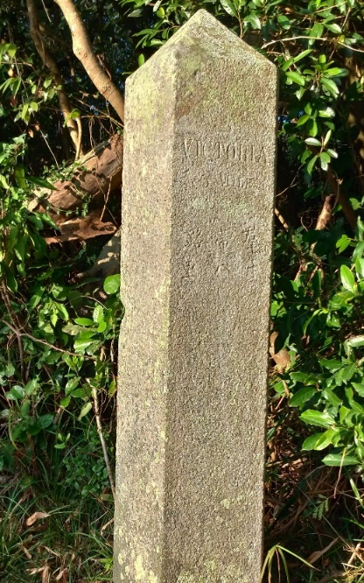
Near Kau Wai Village is a stream that flows from Brick Hill to Aberdeen Channel. As the stream is famous for its sweet tasting water, it was also called the “Fragrant River (香江)”, which later became a refined name for Hong Kong. Rumour has it that when the British Empire first landed in Hong Kong, a fishman named Kwan guided them through the Staney region. The path they took covered nowadays Deep Water Bay Road, Wong Chuk Hang Road,
Aberdeen Main Road, Shek Pai Wan Road, and Pok Fu Lam Road, ultimately stopping at Sai Ying Pun. When asked what the placed in called, Kwan answered “Hong Kong”, leading to the island being named “Hong Kong Island”. In the government issued maps in 1898, the Kau Wai Village area was marked as “Little Hong Kong”.
Kwan Tai Lo Milestone near Tai Tam Reservoir Road

- The stream flowing through Brick Hill and Aberdeen Channel is known for being sweet, earning the name .

- Rumour has it that a fisherman named . lead the British forces upon their landing.

3. If you were a fisherman back then, would you lead the way for the British forces? Why or why not?

Answer：
- Fragrance River
- Kwan
- Any reasonable answer.

