
Empathy, Caring
Worksheet
Tung Wah Hospital
姓名：
班別：
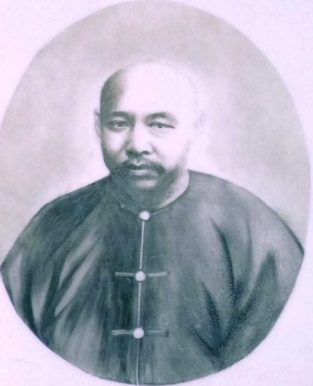
Leung On, Chairman of the Founding Board of
Tung Wah Hospital
Leung On, Chairman of the Founding Board of Tung Wah Hospital, was a senior comprador of Gibbs, Livingston & Co.. His responsibility was to liaison for foreign merchants in Hong Kong, translating for and representing foreign merchants to negotiate with the Chinese government. His kind-heartedness, political intelligence, and leadership skills made him the Founding Chairman of Tung Wah Hospital. The year before the establishment of Tung Wah Hospital, the British colonial government found out an indiscriminate mix of the dead and dying huddled together in the nearby Kwong Fook I-tsz (廣福義祠), a small temple at Tai Ping Shan Street. The act of sending dying patients to be piled with the dead is seen as murder by the Governor of Hong Kong, and he threatened to convict those who did so for murder.
Leung On explained to the Governor that it is a Chinese taboo for family members to die at home, hence sending dying family members to the I-tsz is part of local customs rather than murder. Leung On was seen as the local leader by speaking out for the community, and served as the Chairman of Tung Wah Hospital in 1869, 1870, 1871, and 1877.
- As a comprador, what were Leung On’s responsibilities?

- What was Leung On’s role in the controversy surrounding the sending of dying family members to Kwong Fook I-tsz?

3. If you were living in that day and age, would you follow the customs and send dying patients to the poor conditions of the I-tsz?

Answer：
- Translating for and representing foreign merchants to negotiate with the Chinese government.
- He spoke up for the local community, explaining that this is an act of Chinese customs, not an act of murder.
- Any reasonable answer.

