
Form 2, Unit 1; Form 3, Unit 1 – National Education
Worksheet
Sung Wong Toi
姓名：
班別：
Sung Wong Toi:
the scholar who mourned the Song Emperors

After the 1911 Revolution, a former Qing Dynasty government official by the name of Chen Botao, in defiance of the Nationalist government of the Republic of China, became a hermit in Kowloon City, Hong Kong. He was intrigued by the route of exile taken by the Southern Song Dynasty Royal Family, and frequently invited other members of the Qing government to come visit. In 1916, accompanied by around a dozen of his acquaintances, they visited Sung Wong Toi in memory of Zhao Chouxiao, a loyal subject of the Song Dynasty, and wrote poems to express the sorrows of losing one’s nation.
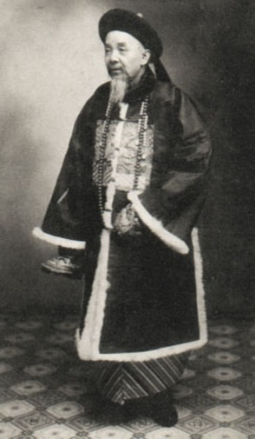
They also wrote further poems about the history of Sung Wong Toi and Kowloon City, spanning from the Southern Song Dynasty to then present day, and complied them into the book “Autumn Chants on the Terrace of the Song Kings (宋臺秋唱)”. The book was highly rated by Lo Hsiang-lin, a Chinese linguist, marking a crucial moment in Hong Kong’s literary history, and added historical significance to Sung Wong Toi.
- What underlying emotions were Chen and his companions hinting at through writing poems about the demise of the Song Dynasty?

- What are your thoughts on them expressing their true thoughts above through composing about the Song Dynasty?

3. Have you ever tried to express your feelings through artistic creation?

Answer：
- Their sorrow towards the demise of the Qing Dynasty
- Any reasonable answer.
- Any reasonable answer.

