
Form 3, Unit 2: Resilience, Benevolence, Responsibility
Worksheet
Kowloon Walled City
姓名：
班別：
Kowloon Walled City:
the lingering memories post-deconstruction
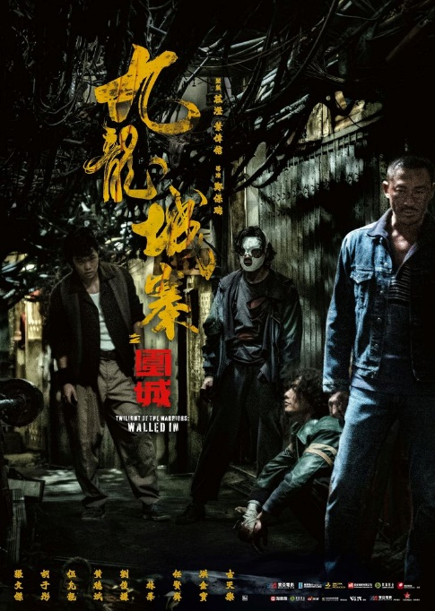
Due to complicated historical reasons, Kowloon Walled City was intentionally left ungoverned by the Qing Dynasty, the British Empire, and later the Hong Kong government alike. In the 1980s, as discussions about Hong Kong’s future resurfaced, the Hong Kong government announced the deconstruction of Kowloon Walled City, and the original site would be redeveloped into a public park. Hong Kong’s legislation would also be applied to within Kowloon Walled City, a notion seconded by the then Chinese government. As such, the mysterious and unique Kowloon Walled City became part of history.
People’s impression towards Kowloon Walled City nowadays were mostly influenced by movies, such “Crime Story” (starring Jackie Chan), “Long Arm of the Law” (directed by Johnny Mak), “Days of Being Wild” (directed by Wong Kar-Wai). The recent movie “Twilight of the Warriors: Walled In” (directed by Soi Cheang) used CGI technology to recreate Kowloon Walled City.

- Due to complicated historical reasons, Kowloon Walled City was left in an state by the Qing Dynasty, the British Empire, and the Hong Kong government.
- Kowloon Walled City was deconstructed in 1987 because of:
  - Sanitary reasons
  - Being part of the discussion of Hong Kong’s future
  - Worsening law and order

  - All of the above
3. Kowloon Walled City was a hotbed of crime before its deconstruction. Do you think its memories is worth preserving?

Answer：
- Ungoverned
- B
- Any reasonable answer.

