
Form 3, Unit 2: National Identity
Worksheet
Golden Bauhinia Square
姓名：
班別：
Golden Bauhinia Square:
learning about the Hong Kong Orchid

The Hong Kong Orchid, official name Bauhinia × blakeana, was first discovered in Hong Kong around 1880 by a French Catholic Missionary, is a hybrid between Bauhinia variegata and Bauhinia purpurea. Its flower blooms big and bright with a feint aroma.
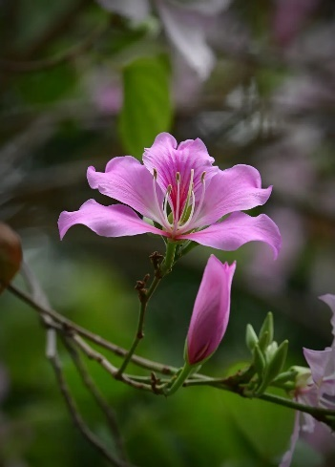
It was adopted as the floral emblem of Hong Kong by the Urban Council in 1965, frequently appearing on coins and stamps. As the five petals of Hong Kong Orchid corresponds with the five stars of China’s national flag, Hong Kong Orchid was adopted as the Emblem of Hong Kong in 1997 upon the Handover of Hong Kong.

- When was the Hong Kong Orchid discovered?
  - 1880
  - 1965
  - 1997

  - 1970
- What are the design philosophies behind the Emblem of Hong Kong?

3. How has the design of the Emblem of Hong Kong inspired you?

Answer：
- A
- Any reasonable answer.
- Any reasonable answer.

