
Form 3, Unit 1: Resilience, Benevolence, Responsibility
Worksheet
Sham Shui Po Barracks
姓名：
班別：
Sham Shui Po Barracks: Lindsay Tasman Ride’s rescue mission

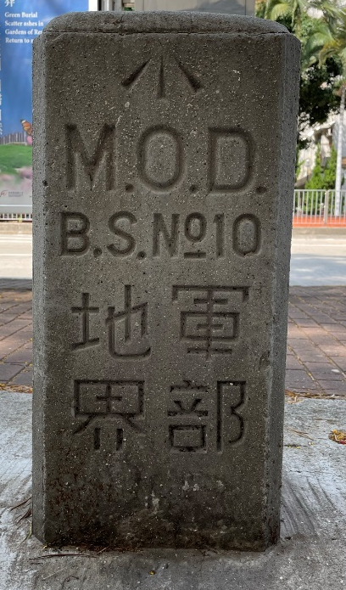
After Japan’s occupation of Hong Kong, Lindsay Tasman Ride, commander of the Hong Kong Field Ambulance, became a prisoner of war and was held in the prison established by the Japanese at the Sham Shui Po Barracks. The poor condition at the barracks made many prisoners fell ill, but the Japanese forces refused to supply the necessary medical equipment to cure the sick. Ride believed that there were only two ways to save the sick prisoners: (1) mobilise external political influence to pressure the Japanese to improve the treatment of prisoners; or (2) smuggle in medicine from China to the prisoner camps. Both methods required Ride to risk his life to escape from the Japanese. On 9th Jan 1942, he managed to escape with two other army officers. They joined the East River guerrillas (later known as the East River Column) at Sai Kung, and was later escorted to Huizhou. There Ride formed and commanded the British Army Aid Group in May 1942, responsible for gathering intel and assisting prisoners of war and internees to escape from the Japanese camps.
- What were the difficulties faced by the prisoners of war at the Sham Shiu Po Barracks?

- What is the name of the entity formed by Lindsay Tasman Ride in 1942?

3. If you were Ride, would you continue undergoing rescue missions upon your escape?

Answer：
- The poor condition at the barracks made many prisoners fell ill, but the Japanese forces refused to supply the necessary medical equipment to cure the sick.
- The British Army Aid Group
- Any reasonable answer.

