
Form 2, Unit 1: Proactivity
Worksheet
Yi Tai Study Hall
姓名：
班別：
Yi Tai Study Hall

In the 19th Century, Kam Tin had a plethora of famous schools, with Yi Tai Study Hall being the most outstanding institute, so much so that scholars took pride in teaching at Yi Tai. Unlike similar buildings, the main entrance opens on the side between the two halls. The forecourt of the study hall is paved with white stones, so it is commonly known as “White Stone Lane”. White Stone Lane is sides by rows of bamboo, reflecting the traditional Chinese virtues of a scholar. Those who study at Yi Tai are often called “White Stone Pupils”, a prestigious status.
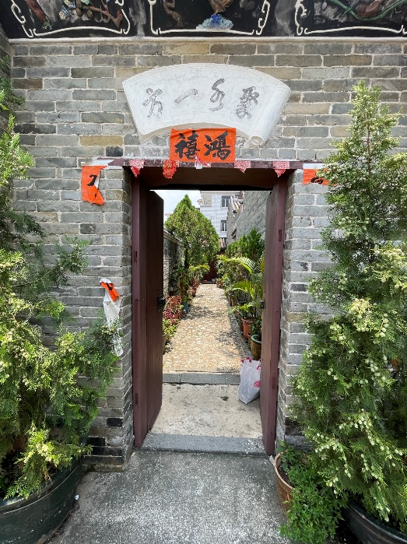 White Stone Lane

- What are two pieces of evidence that Yi Tai Study Hall is an outstanding institute?

2. What are your thoughts on the design of White Stone Lane?

Answer：
- Scholars take pride in teaching at Yi Tai; “White Stone Pupils” is a prestigious status
- Any reasonable answer.

