
Form 3, Unit 1: Resilience, Unity, Responsibility
Worksheet
Devil’s Peak
姓名：
班別：
Devil’s Peak: Hong Kong’s “Dunkirk”

12th December, 1941, the British Empire forces garrisoned in Hong Kong were not able to hold back the invasion of the Empire of Japan, thus decided to retreat to Hong Kong Island. Over 1000 soldiers, alongside with supplies such as horses and firearms, waited around Devil’s Peak to ferry across the 500-metre-wide Victoria Harbour Channel. However, it is a massive challenge to transport massive amounts of forces and supplies, and to successfully retreat from the Japanese forces. The Commander, Captain Arthur John Dewar, voyaged from Taikoo Dockyard with ships and boats, and sailed to Devil’s Peak at sundown for the rescue mission. Though the assigned sailors have fled the scene, Dewar still braved the journey on his own, successfully extracting the 1200 soldiers at Devil’s Peak.
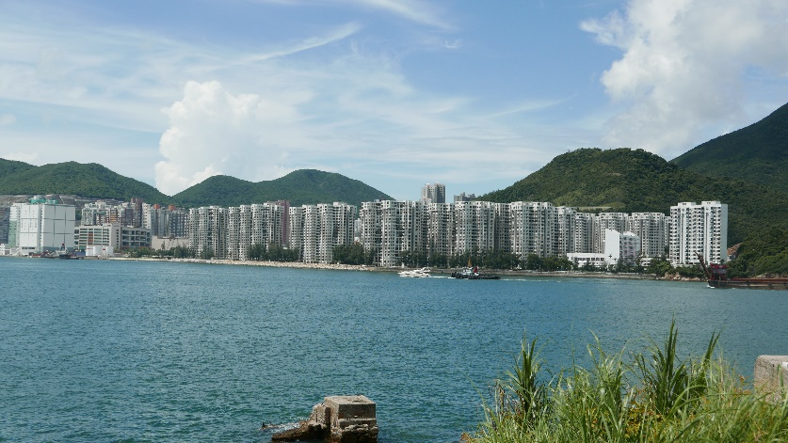 Victoria Harbour Channel

- Which of the following description on the retreat of the British Empire forces on 12th December, 1941 is incorrect?
  - There were over 1000 soldiers stationed at Devil’s Peak
  - The retreat involved supplies such as horses and firearms
  - Captain Arthur John Dewar organised the extraction, but was not present on the extraction boats

  - 1200 soldiers were successfully extracted under Dewar’s command
2. What characteristics of Dewar was demonstrated in this event?

Answer：
- C
- Any reasonable answer.

