
Form 2, Unit 3, Chapter 2 – Conflict in the late Qing Dynasty, National Education
Worksheet
Jao Tsung-I Academy
姓名：
班別：
Kowloon Customs Boundary Stone in Jao Tsung-I Academy
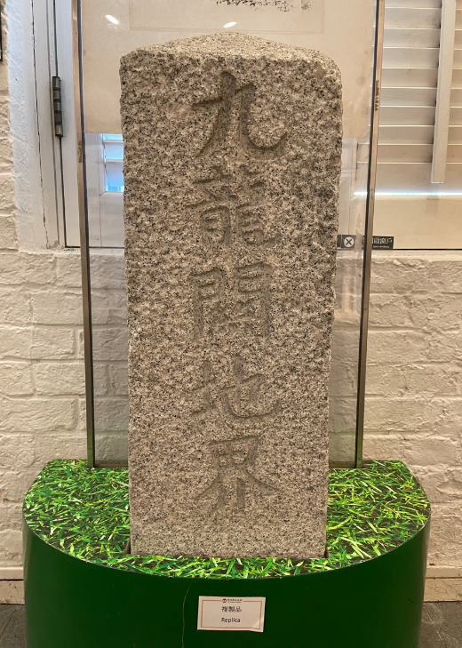
An original Kowloon Customs Boundary Stone is situated in Jao Tsung-I Academy, a relic of the Kowloon Customs that was built in 1887. As Britain occupied Kowloon Peninsula at the time, with Sham Shui Po being the border of the colony, customs stations were established along the border. The Kowloon Customs were managed by westerners, who introduced modern management methods. The customs stations’ primary function was to impose tariffs on opium, collect business tax on inland goods, and combat Hong Kong-based opium smuggling. As customs stations are usually set up near the sea, and Lai Chi Kok perched on a hill overlooking the sea before later reclamation, a branch of the Kowloon Customs was built in this area. After 1898, Britain occupied the New Territories, and the border of the colony was extended. Consequently, the Kowloon Customs – designed to manage Hong Kong’s borders – lost its convenience and purpose, and was later shut down.
Pottery house model with animal pen
- When was the Kowloon Customs Boundary Stone established?
  - 1875
  - 1887
  - 1890

  - 1898
- What is the primary function of the Kowloon Customs?
  - Collect land value tax
  - Combat opium smuggling
  - Monitor British troops

  - Promote trade and commerce
3. What are your thoughts on the establishment and shut down of the Kowloon Customs?

Answer：
- B
- B
- Any reasonable answer.

