
Form 3, Unit 2: Resilience, National Identity
Worksheet
Spiral Lookout Tower
姓名：
班別：
Spiral Lookout Tower:
Remembering the New Territories villagers

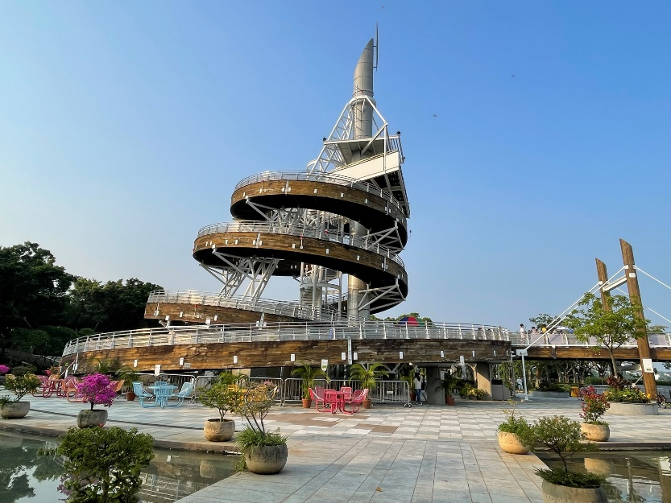
Upon the signing of the Convention for the Extension of Hong Kong Territory, the New Territories was leased to the British Empire. Several police officers were sent to the Tai Po Market (now Tai Wo) to take control over the New Territories, but retreated upon being surrounded by Tai Po villagers. The next day, over a hundred British soldiers arrived at Tai Po on boat, and the Spiral Lookout Tower is built on where the soldiers landed. The villagers’ refusal to accept British ruling lead to plenty of conflicts with the British army, with one fight in particular involving over 1200 villagers and 500 deaths. After the Handover of Hong Kong in 1997, the Spiral Lookout Tower was built in memory of these villagers.

- Which of the following is why the Spiral Lookout Tower was built?
  - Celebration of the Handover of Hong Kong
  - Commemorate the villagers who defied the British Empire
  - Mourning the passed away British soldiers

  - Commemorate the destroyed villages
2. What characteristics are shown from the villagers’ actions, and how should we learn from them?

Answer：
- B
- Any reasonable answer.

