
Form 3, Unit 1, Chapter 3 – Japan’s Invasion of China and the Anti-Japanese War
Worksheet
The Peninsula Hong Kong
姓名：
班別：
Room 336
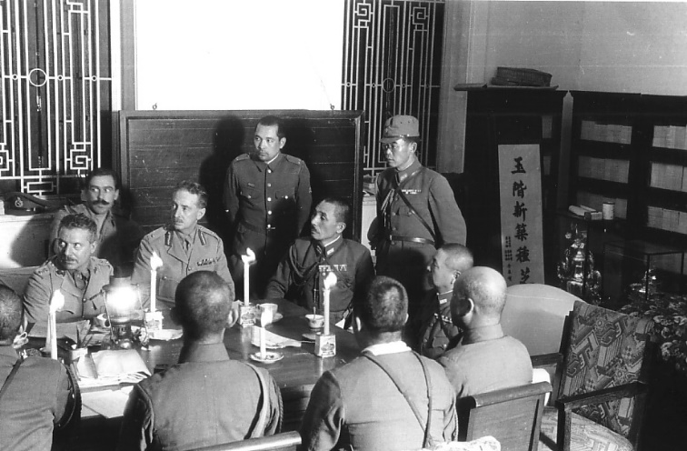
The Peninsula Hong Kong opened in Tsim Sha Tsui in 1928, situated in what was then a transportation hub. As a colonial-style luxury hotel, the Peninsula became a popular meeting place for the upper class and a place to spot celebrities. Upon the forces of the Empire of Japan invading Hong Kong in 1941, the British Empire forces garrisoned in Hong Kong found their defense untenable. On 25th December, the Governor of Hong Kong, Sir Mark Aitchison Young, surrendered in Room 336 of the Peninsula. As the war destroyed the generators, the surrender papers were signed under candlelight. Though the room has been renovated, visitors can still go on a historical voyage to the hotel’s Archive Room, home to many treasures of The Peninsula’s storied existence.

- Which of the following descriptions about the Peninsula is INCORRECT?
  - It was located in Tsim Sha Tsui, a transportation hub
  - It was a popular meeting place for the upper class
  - It has an Archive Room

  - d. It has a back-up generator to provide emergency electricity
- What happened in Room 336 of the Peninsula?
  - The forces of the Empire of Japan planned their attack on Hong Kong Island in the room
  - The forces of the Empire of Japan negotiated the surrender of Sir Mark Aitchison Young in the room
  - Sir Mark Aitchison Young signed the surrender papers in the room
  - d. The British Empire forces planned their counter-attack on the Empire of Japan in this room

3. How did your trip to the Peninsula inspired you?

Answer：
- D
- C
- Any reasonable answer.

