
Form 2, Unit 1: Proactivity, Resilience, Benevolence
Worksheet
Holy Trinity Cathedral
姓名：
班別：
Holy Trinity Cathedral: the exiled Song Dynasty Royal Family
Towards the end of the Southern Song Dynasty, the Royal Family fled South from the pursuing Yuan soldiers. Plaques were laid down along the escape route in their memory. Do you know their correlation?
1. Name of the person that corresponds to each historical site.
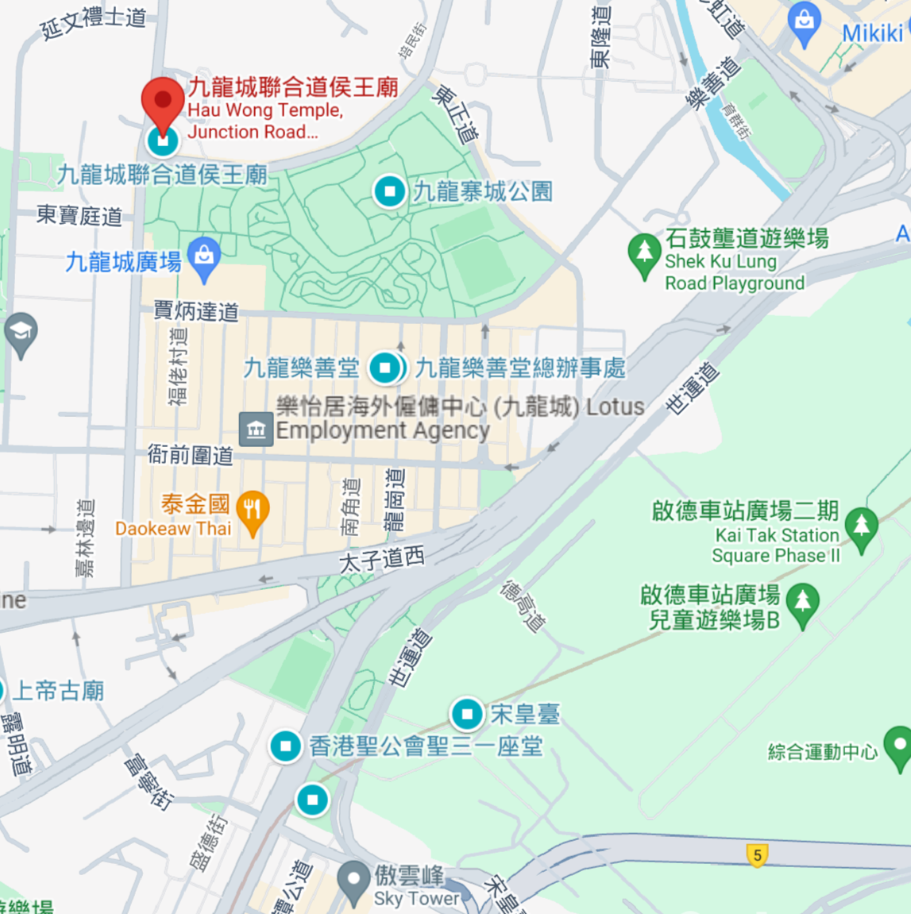
Holy Trinity Cathedral
C：

Sung Wong Toi
B：

Hau Wong Temple
A：
2. Fill in the correct relationship between these people.

Mother Maternal Uncle Elder Brother

Elder Brother
Yang Liangjie
Emperor Duzong
Lady Yang

B
Father
Father
A
Mother

C
Princess Jin
Emperor Duanzong
Emperor Bing

A：______________ B：______________ C：______________

3. If you and your family faces great adversity, how would you respond?

Answer：
- A: Yang Liangjie; B: Emperor Bing; C: Princess Jin
- A: Mother; B: Maternal Uncle; C: Elder Brother
- Any reasonable answer.

