
Form 1, Unit 4
Worksheet
Tsing Shan Monastery
姓名：
班別：
Tsing Shan Monastery:
The legend of Pui To (杯渡禪師)

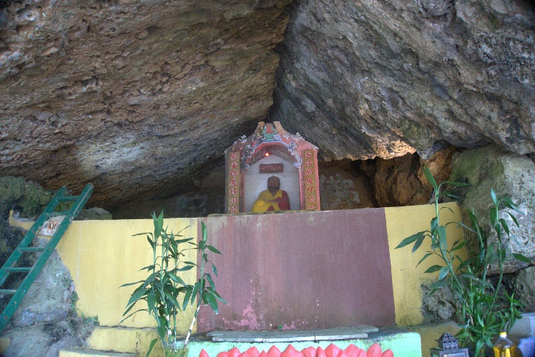
The legends of Pui To describe him as an eccentric figure. His myths speak of deeds like walking bare feet in the streets, bathing in frozen lakes, being able to duplicate himself, and even returning from the dead. He is also known to be medically gift, and has cured many diseases. In the South Song Dynasty, during the 5th year of Emperor Wen of Song’s reign (428 AD), Pui To left the Yangtze River region and departed to Guangdong, Guangxi, and nowadays Vietnam. Even though Pui To’s stories are somewhat bizarre, and having no records of his nationality and origins, but according to the Memoirs of Eminent Monks, people have seen Pui To in Jianye (建業, nowadays Nanjing) in his forties. Hence it is likely that Pui To is an actual historical figure.

- Which of the following is Pui To’s characteristics?
  - Kind and polite
  - Eccentric and walks around bare feet
  - Elegant and academic

  - Has a close relationship with government officials
2. What are your thoughts on the legend of Pui To? Is he similar to what you normally think monks are like?

Answer：
- B
- Any reasonable answer.

