
Form 1, Unit 1 – Chinese Culture
Worksheet
Rock Carvings at
Wong Chuk Hang
姓名：
班別：
Rock Carvings at Wong Chuk Hang:
The meaning of “beast face carvings”
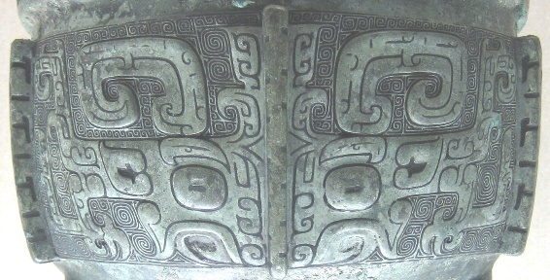
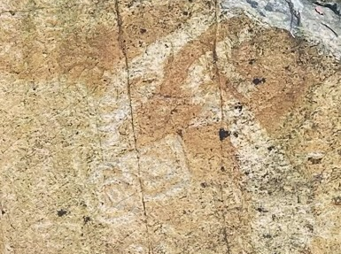
There are several carvings shaped like a beast’s face at the Rock Carvings at Wong Chuk Hang. These beast face carvings represent an imaginary monster, Gluttony (饕餮). Gluttony has no body, only a head and a big mouth, and eats everything it sees. Gluttony ultimately died from being stuffed to death, and is seen as a symbol of excessing greed. The carvings of Gluttony are first seen from jade articles unearthed in Liangzhu, China, believed to be 5000 years old. The carvings are also commonly seen on tripods from the Zhou Dynasty. Ancient Chinese people believe that the carving of such a fierce monster can scare away unknown natural disasters, and made such carvings on stones for protection.
Rock Carvings at Wong Chuk Hang
Rock Carvings at Wong Chuk Hang

- The carvings at the Rock Carvings at Wong Chuk Hang that takes the shape of a beast’s face are called ______________________.

- The mythical monster is called Gluttony, a representation of ______________________.

3. Do you like these ancient carvings? Why or why not?

Answer：
- beast face carvings
- greed
- Any reasonable answer.

