
Chinese pottery art; Intangible cultural heritage
Worksheet
Tin Hau Temple
姓名：
班別：
Shiwan Ceramics
The Hau Wong Temple at Shau Kei Wan was built in 1873 towards the end of the Qing Dynasty. Despite having a typical temple layout, the ceramics on top of the temple’s roof ridge are both visually impressive and hold historical value.
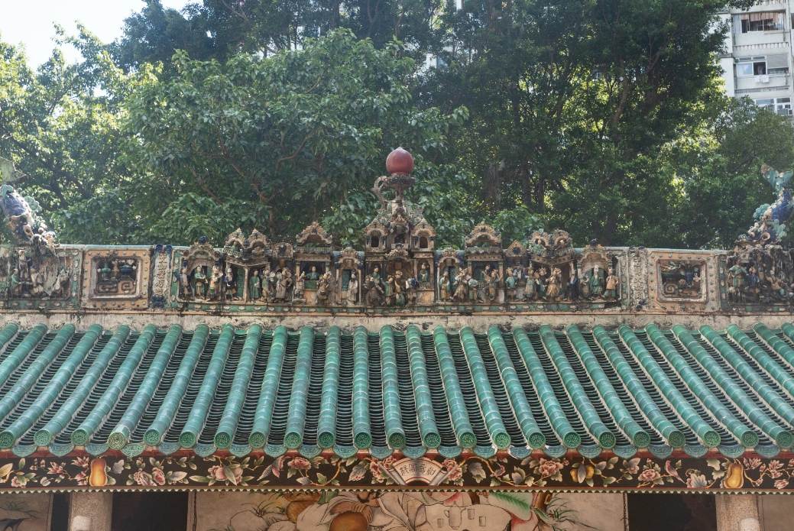
Shiwan Ceramics originated from Shiwan, Foshan, Guangdong Province. These ceramics started collector’s items, then people began to place sculptures of heroic figures and/or those with meanings of good luck atop roof ridges, both as decorations and to attract good omen. Compared to traditional ceramics, Shiwan Ceramics are better at mimicking the texture of skin and flesh, making their sculptures look more realistic.

- Compared to normal ceramics, Shiwan Ceramics are better at mimicking
, making their sculptures look more .

2. How can traditional crafts be inherited by future generations?

Answer：
- the texture of skin and flesh; realistic
- Any reasonable answer.

