
Chinese calligraphy and painting art
Worksheet
Lo Pan Temple
姓名：
班別：
Lo Pan Temple’s Ink Paintings
As Lo Pan (魯班; also transliterated as "Lu Ban") is seen as the patron saint of Chinese builders and contractors, the temple dedicated to Lo Pan made use of elaborate and intricate decorations. Over the plaque at the entrance, there are a variety of impressive ink paintings, accompanied by varying styles of calligraphy.
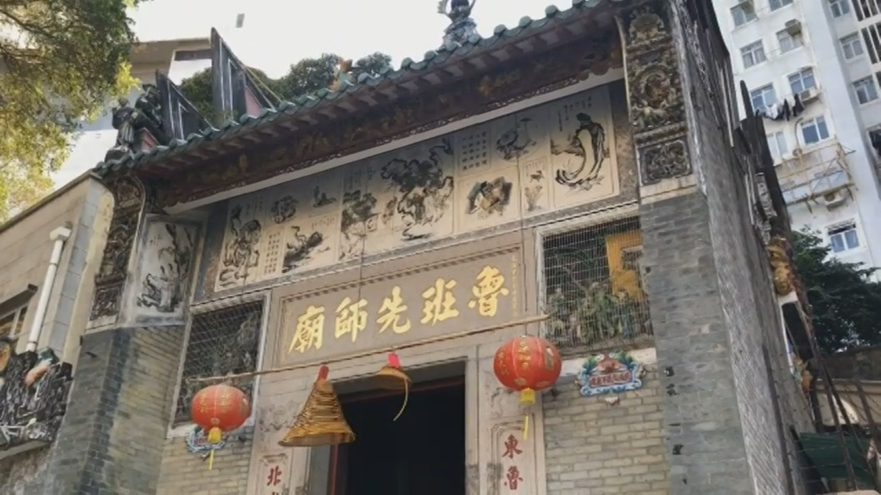
The two paintings that stood out the most were the ones of two famous figures from folklore and legends, Iron Crutch Li (鐵拐李) and Bodhidharma (達摩祖師), with distinct contrasts within the paintings’ composition. For example, the curved outline of Bodhidharma contrasted heavily with the straightness of the mountains in the background. There are also contrasts across the two paintings, such as the contrast between the
smoothness and the roughness of their outlines, or how one wears a hat when the other doesn’t. This way of composition and framing is unique.

- Over the plaque at the entrance of Lo Pan Temple, there are a variety of impressive , with the two that stood out the most being of
and , two famous Chinese figures.
- There is a strong theme of on the two paintings, both within each painting and across them both.

3. The craftsmen added elaborate and intricate decorations to Lo Pan Temple. If you are attending Lo Pan Patron’s Day, what decorations will you design for the temple and why?

Answer：
- ink paintings; Iron Crutch Li; Bodhidharma
- contrast
- Any reasonable answer.

